**Branch visible in Tier 1( BO)**

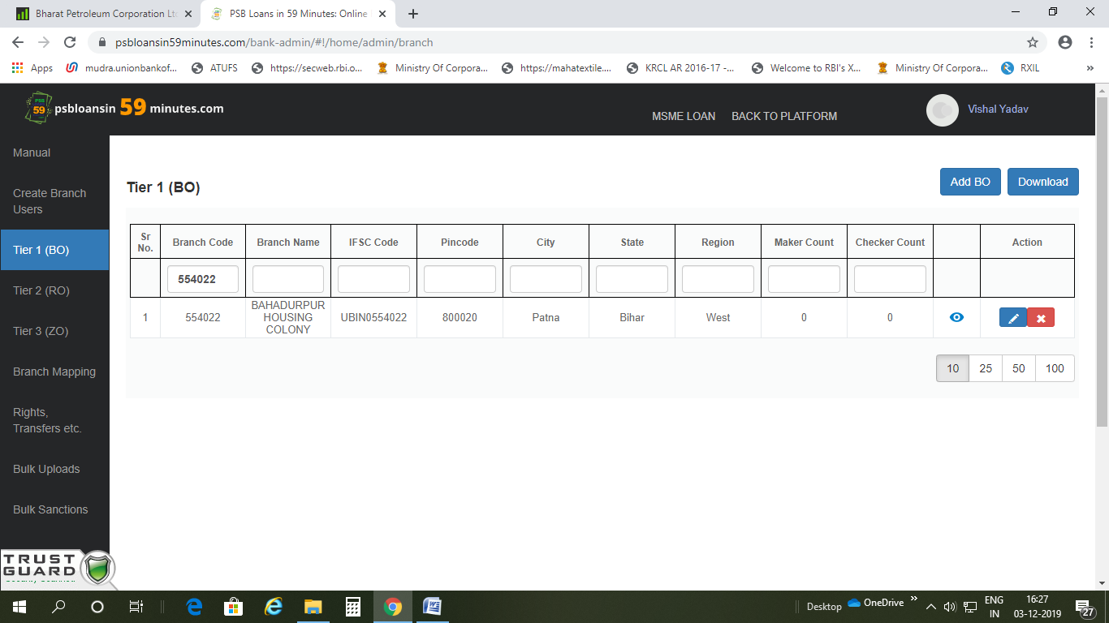

**Branch not visible in Rights,Transfer tab**

